Predicting Airbnb Listing Prices with MLflow and AWS S3

Project Overview
This project predicts optimal nightly prices for Airbnb listings on StayWise, a global vacation rental platform. Accurate price prediction helps hosts set competitive rates and improves booking efficiency. The project uses:
AWS S3: Data storage
MLflow: Experiment tracking and model registry
Machine Learning Models: Regression models for price prediction
Objectives:
Retrieve Airbnb listings from AWS S3
Clean and preprocess the data
Develop and compare multiple regression models
Track experiments and register the best model in MLflow.
Dataset Description
The dataset contains information about Airbnb listings, including price, location, amenities, reviews, and host details. The dataset requires preprocessing to handle missing values, categorical variables, and outliers.
Data Preprocessing:
Handled missing values in 'name' and 'host_name'.
Converted categorical variables using encoding.
Created new features like 'amenities_count'.
Removed outliers using the IQR method.
Split the dataset into training and testing sets.

MLflow Experiment Tracking:
All models were tracked using MLflow, logging metrics, parameters, and artifacts. The best model (Random Forest) was registered in the MLflow Model Registry. Attach MLflow UI screenshots here.

Repository Structure
airbnb-price-prediction/
── notebook.py
── requirements.txt
── .gitignore
── README.pdf

Setup Instructions:
1. Clone the repository
git clone https://github.com/yourusername/airbnb-price-prediction.git
cd airbnb-price-prediction
2. Install dependencies
pip install -r requirements.txt
3. Run Jupyter notebooks
jupyter notebook

Workflow Diagram:
- Retrieve Data from S3
- Data Cleaning & Preprocessing
- Feature Engineering & Encoding
- Train Regression Models
- MLflow Experiment Tracking
- Compare Models & Register Best
- Deploy/Use Model

Data Preprocessing Steps
- Handle missing values (name, host_name, etc.)
- Encode categorical variables (neighbourhood, room_type)
- Handle outliers in price
- Feature engineering: reviews_per_month, amenities_count, etc.
- Normalize and scale numeric features

Model Development & MLflow
Tested regression models:
1. Linear Regression
2. Random Forest Regressor
3. Gradient Boosting Regressor
Metrics tracked using MLflow:
- RMSE
- R² Score

Model Performance
Model | RMSE | R²
Linear Regression | 45.56 | 0.54
Random Forest Regressor | 43.88 | 0.57
Gradient Boosting | 44.55 | 0.56

ML FLOW:
Experiment Tracking UI
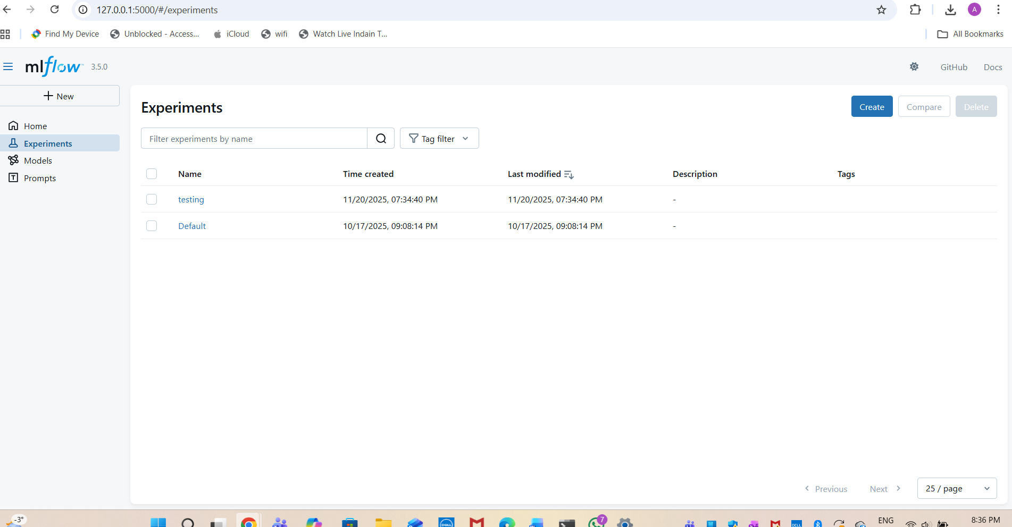

Metrics Comparison:
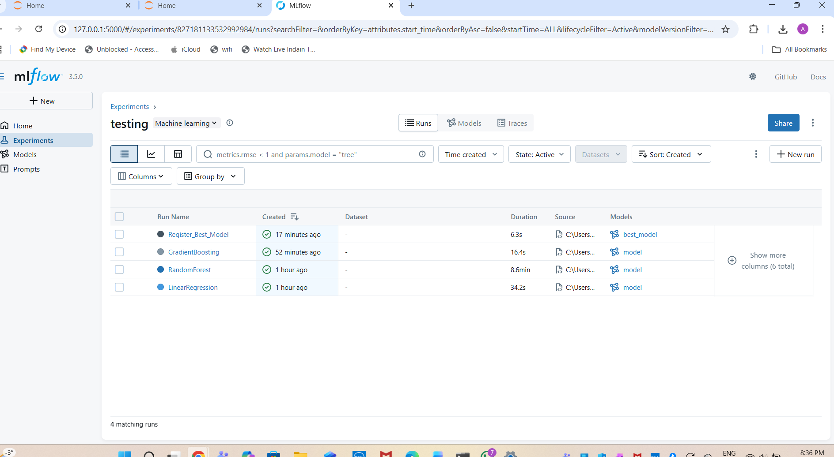
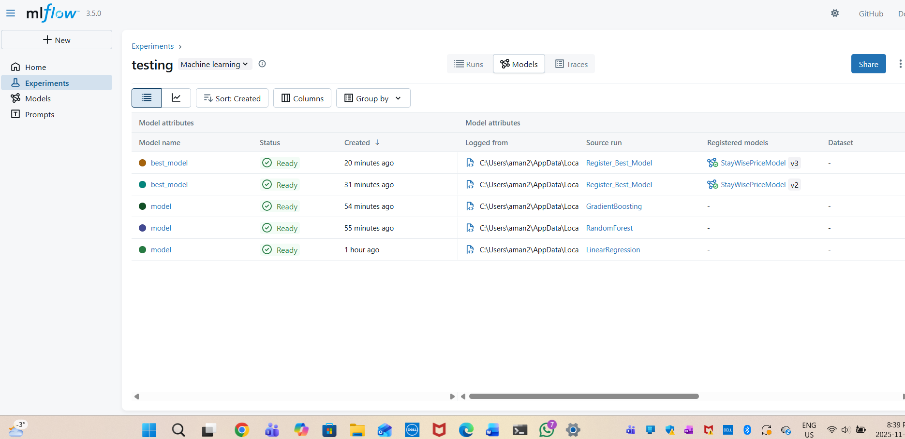
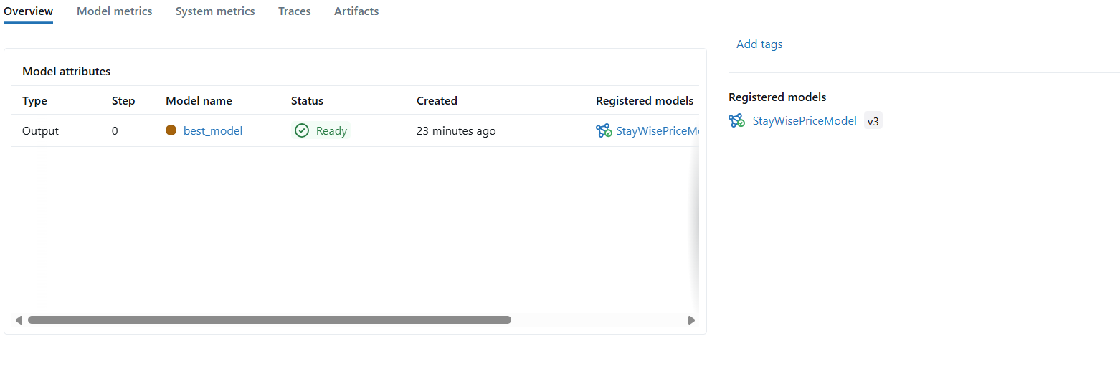Model Registres:
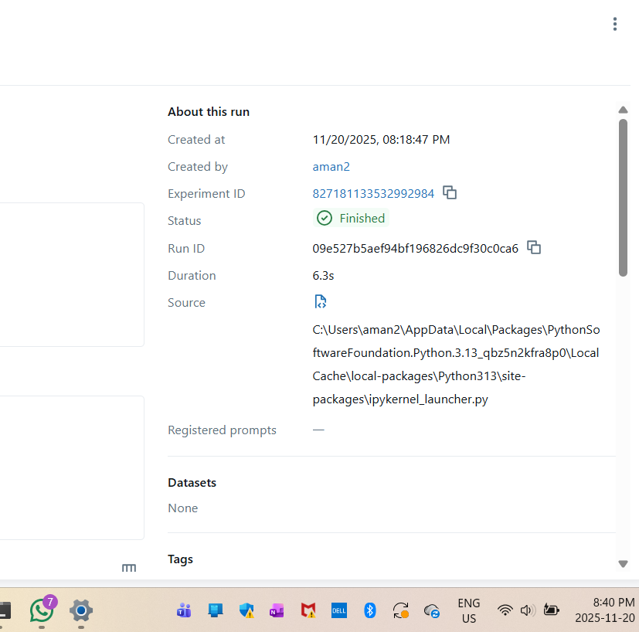

Dependencies:
pandas
numpy
scikit-learn
mlflow
boto3
matplotlib
seaborn

Notes
Ensure AWS credentials have read access to S3.
Large datasets and MLflow artifacts are excluded via .gitignore.
Follow notebook execution order for smooth workflow.
Key insights and observations:
Features like location, number of amenities, and reviews significantly influence price.
Random Forest captures complex relationships better than Linear Regression or Gradient Boosting in this dataset.
Outlier removal improved model performance slightly.
MLflow provides a convenient way to compare model runs and manage model versions.

